Q.1 Using console.log () print out the following statement: The quote 'There is no exercise better for the heart than reaching down and lifting people up.' by John Holmes teaches us to help one another. Using console.log () print out the following quote by Mother Teresa:   
- 

Q.2 Check if type of '10' is exactly equal to 10. If not make it exactly equal?  
- 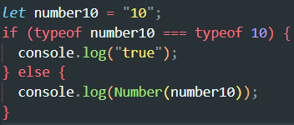   
  
Q3. Write a JavaScript Program to find the area of a triangle?  
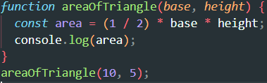  
  
4. Write a JavaScript program to calculate days left until next Christmas?  
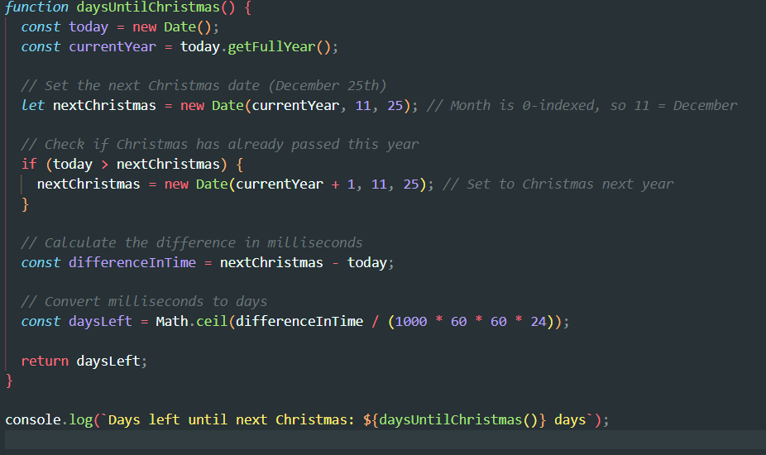

5. What is Condition Statement?  
-In programming, a conditional statement (or conditional expression) is a feature that allows the code to make decisions and perform actions based on certain conditions. It enables programs to execute specific sections of code only if certain conditions are true or false.  
  
6. Find circumference of Rectangle formula : C = 4 * a ?  
- 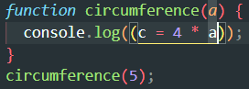

7. WAP to convert years into days and days into years?  
- 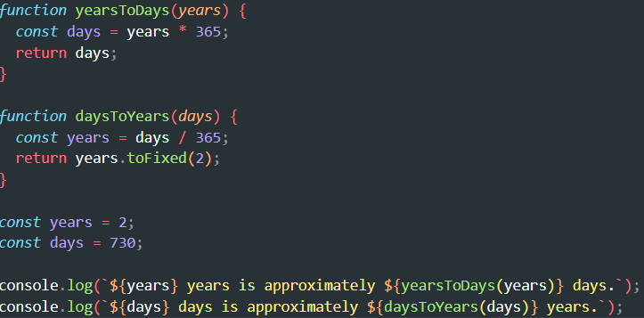  
  
8. Convert temperature Fahrenheit to Celsius?  
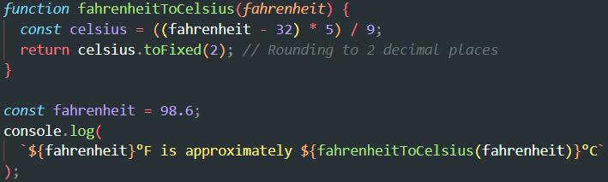

10. What is the result of the expression (5 > 3 && 2 < 4)?  
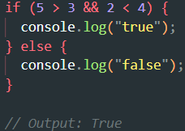  
  
11.What is the result of the expression (true && 1 && "hello")?  
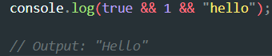  
  
12. What is the result of the expression true && false || false && true?  
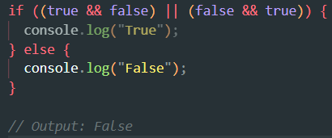  
  
13. Check Number Is Positive or Negative in JavaScript?  
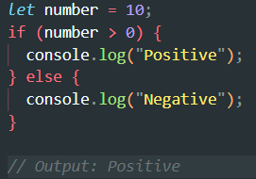  
  
  
**14. Find the Character Is Vowel or Not ?  
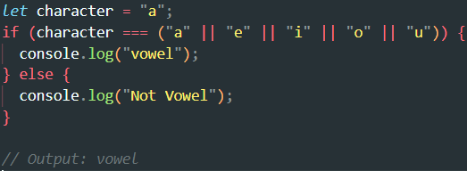**

**15. Write to check whether a number is negative, positive or zero?  
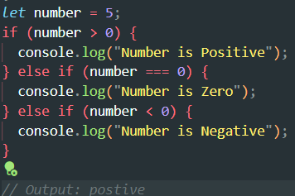  
  
16. Write to find number is even or odd using ternary operator in JS?  
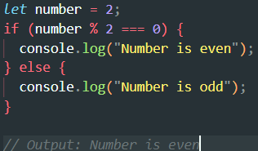  
  
17. Write find maximum number among 3 numbers using ternary operator in JS?  
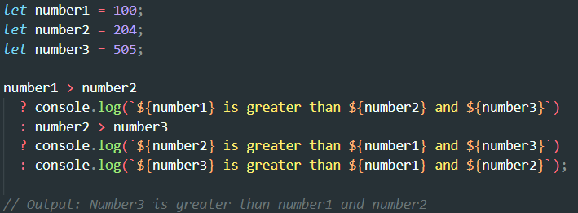**

**18. Write to find minimum number among 3 numbers using ternary operator in JS?  
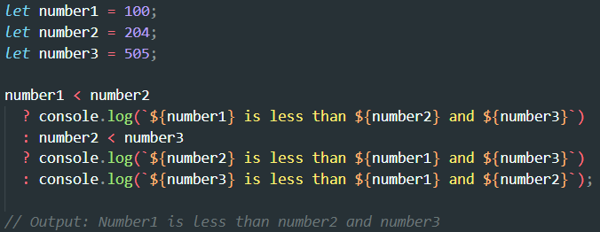  
  
19. Write to find the largest of three numbers in JS?  
  
  
20. Write to show i. Monday to Sunday using switch case in JS? ii. Vowel or Consonant using switch case in JS?  
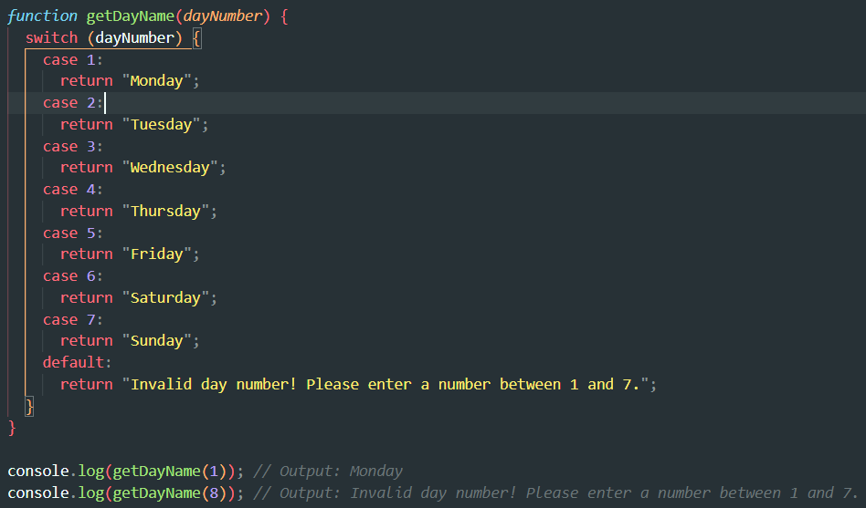  
  
  
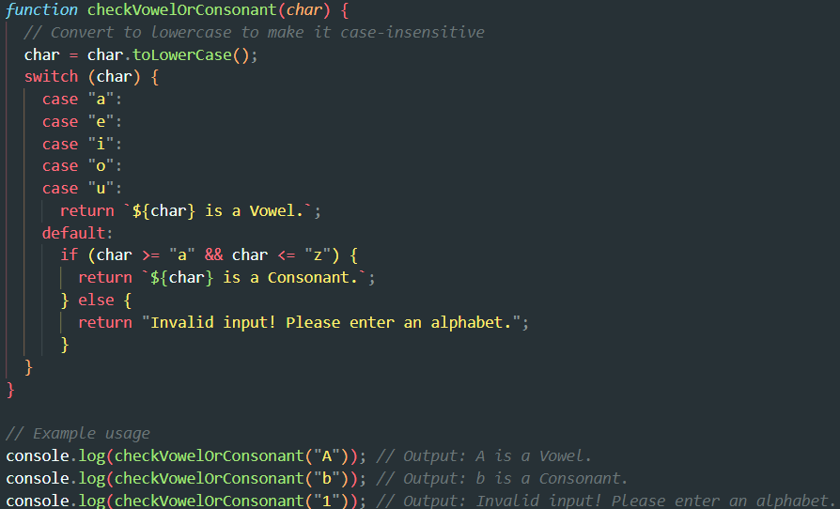  
  
  
  
(Conditional looping logic Question)  
  
  
21. What are the looping structures in JavaScript? Any one Example?**Looping Structures in JavaScript

JavaScript provides several looping structures to execute a block of code repeatedly until a specified condition is met:

for loop

Executes a block of code a specific number of times.

while loop

Executes a block of code as long as the specified condition is true.

do...while loop

Executes a block of code at least once, and then repeats as long as the specified condition is true.

for...in loop

Iterates over the enumerable properties of an object.

for...of loop

Iterates over the values of iterable objects like arrays, strings, or NodeLists.  
  
22. Write a print 972 to 897 using for loop in JS?  
-  
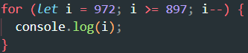  
  
23. Write to print factorial of given number?  
-  
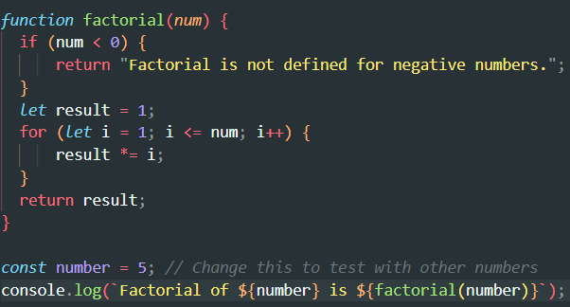  
  
  
  
  
  
  
  
24. Write to print Fibonacci series up to given numbers?  
-  
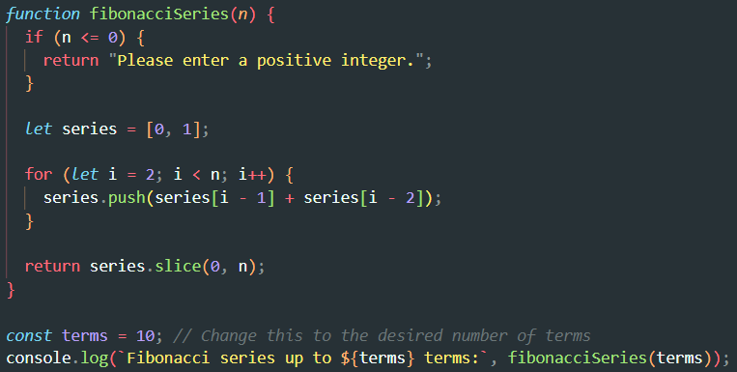  
  
  
25. Write to print number in reverse order e.g.: number = 64728 ---> reverse =82746 in JS?  
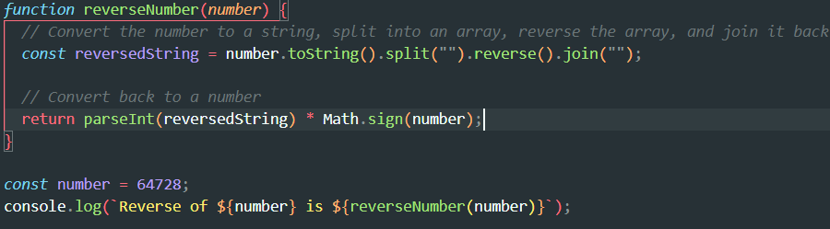  
  
26. Write a program make a summation of given number (E.g., 1523 Ans: - 11) in JS?  
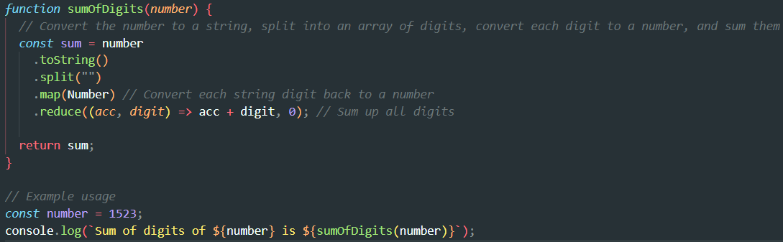  
  
  
  
  
  
  
  
27. Write a program you have to make a summation of first and last Digit. (E.g., 1234 Ans: - 5) in JS?  
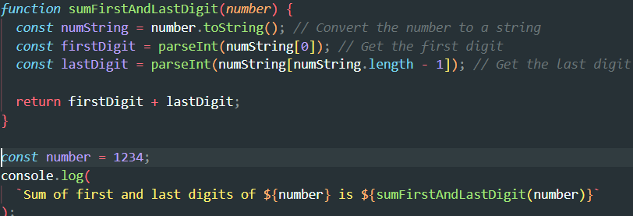  
  
  
28.Use console.log() and escape characters to print the following pattern in JS?  
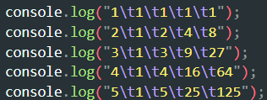  
  
Use pattern in console.log in JS?   
1   
1 0   
1 0 1  
1 0 1 0   
1 0 1 0 1  
  
-  
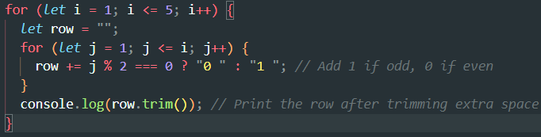  
  
4o mini

**You said:**

A   
B C   
D E F   
G H I J  
K L M N O

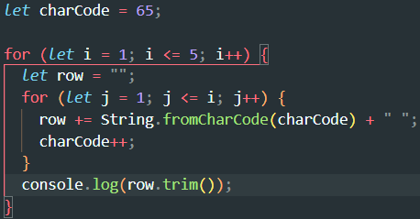  
  
1

2 3

4 5 6

7 8 9 10

11 12 13 14 15  
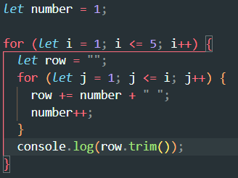

*   
* *   
* * *   
* * * *   
* * * * *  
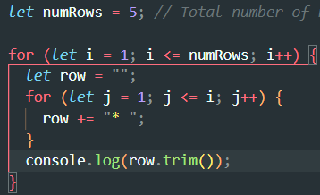  
  
  
Question 1: What is JavaScript? Explain the role of JavaScript in web development.  
- JavaScript is a versatile, lightweight, and high-level programming language primarily used for creating dynamic and interactive content on web pages. It runs in the browser and allows developers to implement features like animations, form validations, real-time content updates, and more.

Question 2: How is JavaScript different from other programming languages like Python

Or Java?  
- JavaScript: Primarily for web development (frontend and backend).  
 Python: General-purpose; widely used in data science, AI, web, and more.  
Java: General-purpose; commonly used for enterprise-level applications.

Question 3: Discuss the use of <script>tag in HTML. How can you link an external

JavaScript file to an HTML document?- The <script> tag is used to include JavaScript in an HTML document. It can embed JavaScript directly or link to an external JavaScript file.  
  
Task:  
  
  
  
Variables and Data Types

Theory Assignment

Question 1: What are variables in JavaScript? How do you declare a variable using var, let,

and const?  
- Variables in JavaScript are containers for storing data values. They allow developers to reuse and manipulate data throughout their programs.  
  
var name = “Lawrence”  
let name = “Nadar”  
const pi = 3.14

Question 2: Explain the different data types in JavaScript. Provide examples for each.  
- In JavaScript there is primitive and non-primitive data type   
Primitive data type:  
1) string, let name= “Lawrence”

2)Number let age= 18

3) Boolean isStudent = true

4)Undefined let score  
5)Null let emptyValue= null  
6)Symbol uniqueId = symbol(‘id’)  
7)BigInt let largerNumber = 123456789012345678901234567890n;  
  
Non-Primitive Data Type  
let person = {name: “Alice”, age: 25}

Question 3: What is the difference between undefined and null in JavaScript?  
- Undefined: A variable that has been declared but not assigned a value.  
 Null: Represents an intentional absence of any object or value.  
Task: 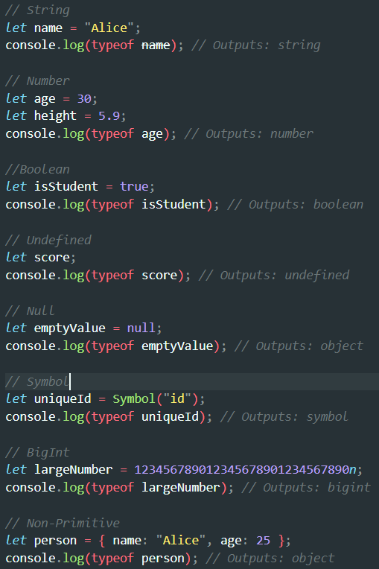

JavaScript Operators

Theory Assignment

• Question 1: What are the different types of operators in JavaScript? Explain with examples.

• Arithmetic operator

Used to perform mathematical calculations.

+ Addition 5 + 3 8

- Subtraction 10 - 4 6

* Multiplication 4 * 3 12

/ Division 20 / 5 4

% Modulus (Remainder) 10 % 3 1

** Exponentiation 2 ** 3 8

++ Increment let x = 5; x++ 6

-- Decrement let y = 3; y-- 2

• Assignment operators

Used to assign values to variables.

= Assignment x = 10 10

+= Add and Assign x += 5 15

-= Subtract and Assign x -= 3 12

*= Multiply and Assign x *= 2 24

/= Divide and Assign x /= 4 6

%= Modulus and Assign x %= 5 1

• Comparison operators

Used to compare two values and return a boolean (true or false).

== Equal to 5 == "5" true

=== Strict equal to 5 === "5" false

!= Not equal to 10 != 5 true

!== Strict not equal 10 !== "10" true

> Greater than 7 > 3 true

< Less than 3 < 7 true

>= Greater or equal 7 >= 7 true

<= Less or equal 4 <= 6 true

• Logical operators  
Used to combine or invert boolean values.

&& Logical AND (5 > 3) && (7 > 4) true

` ` Logical OR

! Logical NOT !(5 > 3) false

• Question 2: What is the difference between ==and ===in JavaScript?  
- difference between Equality and strict Equality  
Equality: Converts operands to the same type before comparison.  
-Only checks value equality.  
  
Strict Equality: Does not perform type coercion.  
-Checks both value and type equality.  
  
Task:  
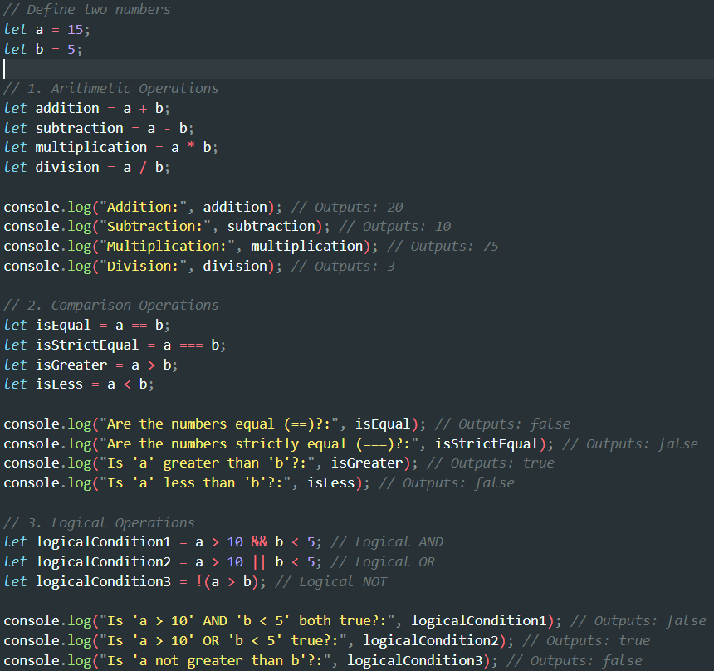

Control Flow (If-Else, Switch)

Theory Assignment

• Question 1: What is control flow in JavaScript? Explain how if-elsestatements work withan

example.   
- Control flow in JavaScript refers to the sequence in which the program's code is executed. By default, JavaScript executes statements from top to bottom. Control flow statements like if-else, switch, loops, and functions allow developers to alter this flow based on specific conditions.  
**If-Else Statement**

The if-else statement is used to execute blocks of code based on a condition:

* **if block** executes when the condition evaluates to true.
* **else block** executes when the condition evaluates to false.

let age = 20;

if (age >= 18) {

console.log("You are eligible to vote.");

} else {

console.log("You are not eligible to vote.");

}  
//Output: You are eligible to vote.

• Question 2: Describe how switch statements work in JavaScript. When should you use a

Switch statement instead of if-else?

- The switch statement is used to execute one block of code out of multiple options based on a specific value.

**How It Works:**

1. A switch statement evaluates an expression.
2. The value of the expression is compared against multiple case values.
3. If a match is found, the corresponding block of code executes.
4. The default case executes if no match is found.
5. Use the break statement to exit the switch after a match; otherwise, code in subsequent cases will also execute.

let fruit = "apple";

switch (fruit) {

case "apple":

console.log("You selected apple.");

break;

case "banana":

console.log("You selected banana.");

break;

default:

console.log("Unknown fruit.");

}  
  
Task 1: • Write a JavaScript program to check if a number is positive, negative, or zero using an if-else statement.  
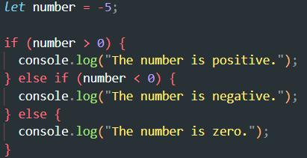  
  
Task 2: • Create a JavaScript program using a switch statement to display the day of the week based on the user input (e.g., 1 for Monday, 2 for Tuesday, etc.).  
  
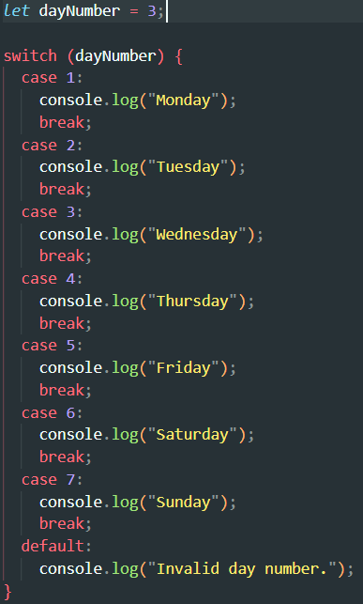  
  
  
  
Loops (For, While, Do-While)

Theory Assignment

• Question 1: Explain the different types of loops in JavaScript (for, while, do-while).

Provide abasic example of each.

Loops in JavaScript allow you to repeat a block of code multiple times. The three main types of loops are for, while, and do-while.

1. For Loop

The for loop is used when the number of iterations is known beforehand. It consists of three parts:

Initialization: Sets the starting point.

Condition: Determines if the loop should continue.

Increment/Decrement: Updates the loop variable after each iteration.  
  
 **2. While Loop**

The while loop executes a block of code as long as a specified condition is true. It checks the condition before each iteration.  
let count = 1;

while (count <= 5) {

console.log("Count:", count);

count++;

}  
  
**3. Do-While Loop**

The do-while loop is similar to the while loop but ensures that the code block executes **at least once**, even if the condition is initially false.

let number = 6;

do {

console.log("Number:", number);

number++;

} while (number <= 5);

• Question 2: What is the difference between a whileloop and a do-whileloop?  
- Aspect  
While Loop: Checks the condition **before** executing the loop.  
Do-While Loop: Checks the condition **after** executing the loop.  
- Execution Guarantee:  
May not execute if the condition is initially false.  
Executes the code block **at least once** regardless of the condition.   
  
task 1:  
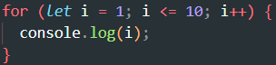  
  
task 2:   
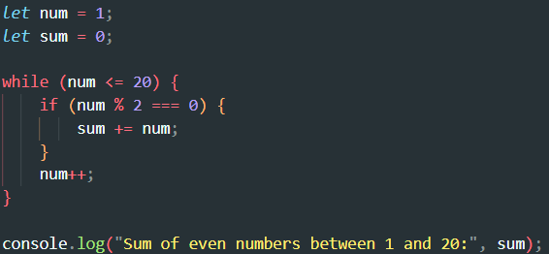  
  
  
Task3:  
